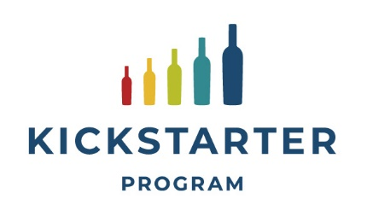

Application 2026/2027

Yes, we are interested in participating in the KICKSTARTER program
- Importer :
- Contact person :
- Email :
- Phone :

We are applying for a Kickstarter event:
- Short description of event: (for example tasting, lunch/dinner, seminar)
- Location :
- Planned date :
- Wineries + wines to be presented :
- # and type of guests :
- Other actions planned (for example special wine offer, instore decoration, newsletter, social media, etc):

We are applying for a Kickstarter bursary:
- Planned date of visit:
- Current wineries to be visited:
- New wineries (not yet in assortment) to be visited:
  - Yes, please send us some suggestions

We hereby agree to the Terms & Conditions as presented on the website.

For any questions, please contact Tania da Costa tdacosta@wineinstitute.org

